MSWC Control Strategy at Returkraft

# Background

Returkraft operates a Municipal Solid Waste Combustion (MSWC) plant, but because of intellectual property rights, we cannot get the principles behind their control strategy from the manufacturer. This document outlines these principles as interpreted from the P&ID-like figures in the plant control panel, as shown in figure 1. Note that several features of the control panel are still unknown. In particular, the "Disturbance" branch will be ignored, and the label "SP Feeder" at the top of the figure is considered misplaced.

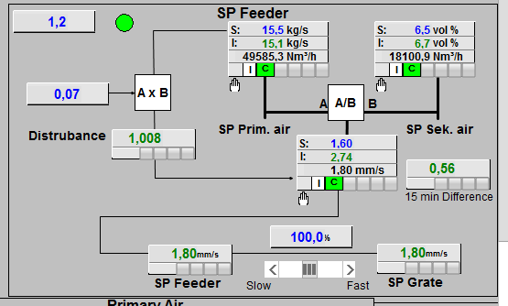

Figure 1. Part of the plant control panel. The main features are believed to be understood, but several details are still unknown.

# The control problem

As in most MSWC plants, the control problem uses four manipulated variables (MVs).

|  |  |  |
| --- | --- | --- |
| **MV** | **Symbol** | **Unit** |
| Primary air flow | F_aI | kg/s |
| Secondary air flow | F_aII | kg/s |
| Combustion grate speed | v_grate | mm/s |
| Waste feed | F_w | mm/s |

Note that the actuators producing these MVs, e.g. the fans driving the air flows, in reality have transfer functions with some delay. However, this document assumes that the MVs can be controlled instantaneously.

Furthermore, there are initially two variables to be controlled (CVs).

|  |  |  |
| --- | --- | --- |
| **CV** | **Symbol** | **Unit** |
| Flue gas oxygen | F_O2 | % |
| Turbine input steam | F_st | kg/s |

Note that several equivalent CVs can be chosen. For example, turbine effect could be used instead of turbine input steam. Even though this can have physical significance because of transport delays, it is not of importance to the general control strategy.

# Step responses

To understand the control strategy, it is important to know the step responses of the system, as shown in figure 2. Note that these were obtained from the SIMULINK model by simply applying step increases to the MVs in a running open-loop simulation and plotting the CV responses. This means that process fluctuations are not subtracted from the responses, but this does not affect the main features. The units on the axes are arbitrary.

## Primary air flow

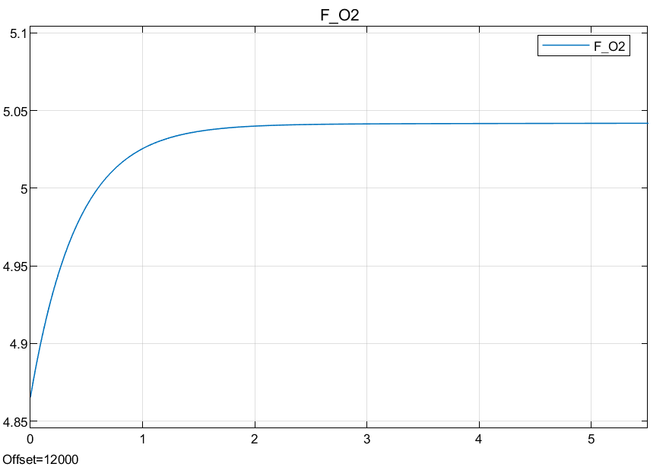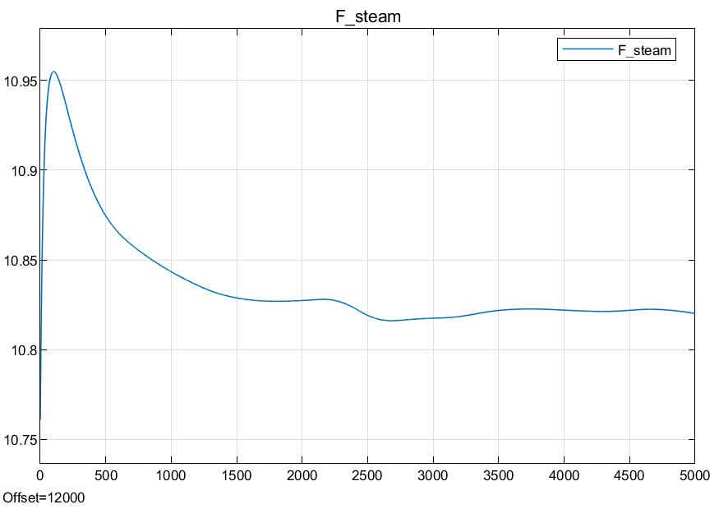

## Secondary air flow

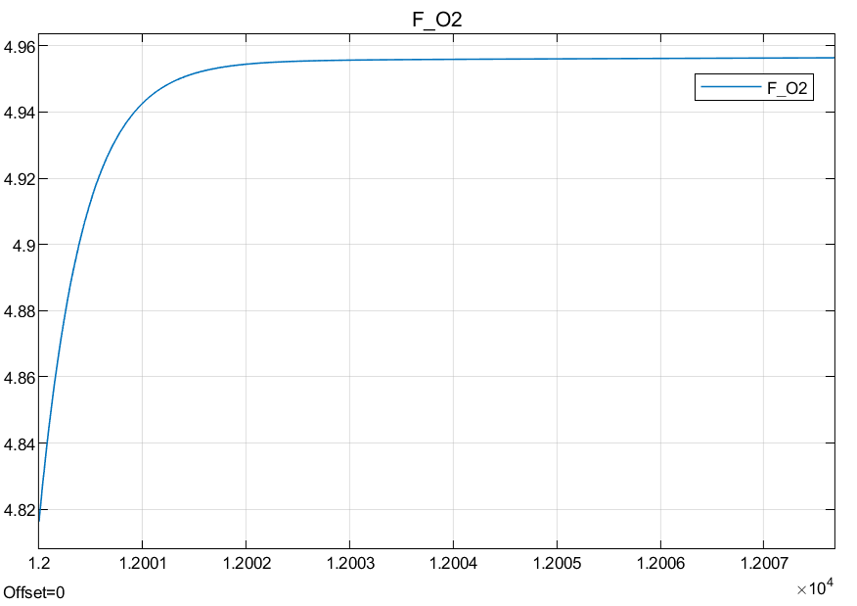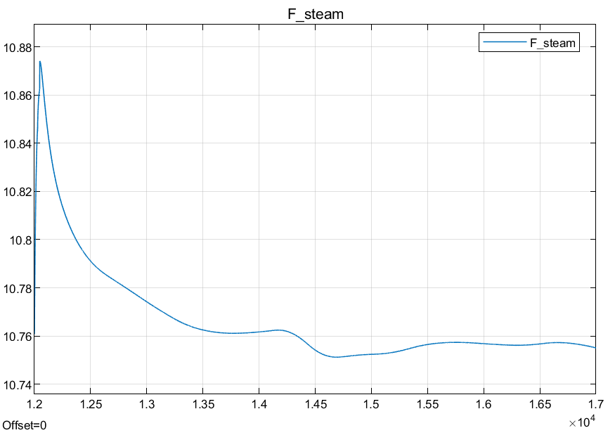

## Grate speed

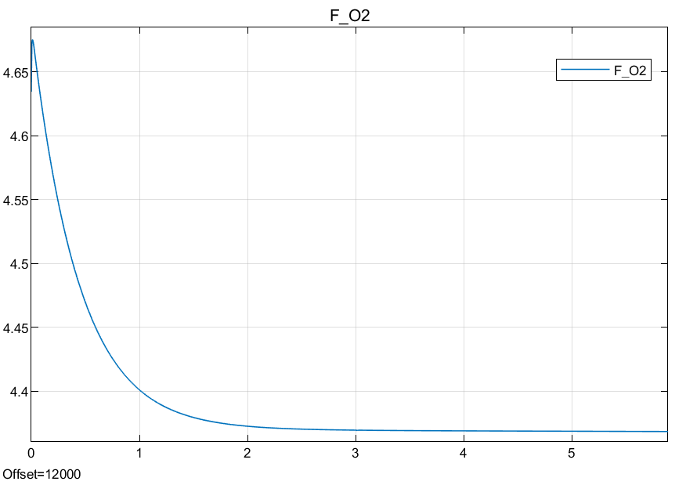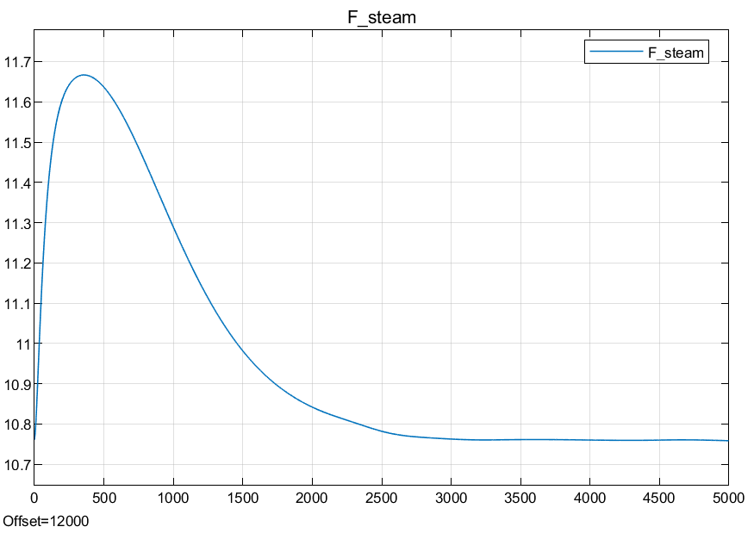

## Waste feed

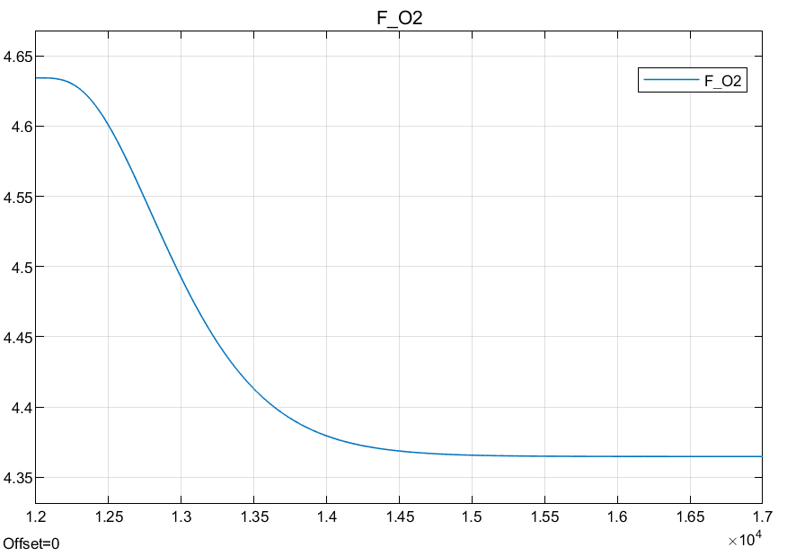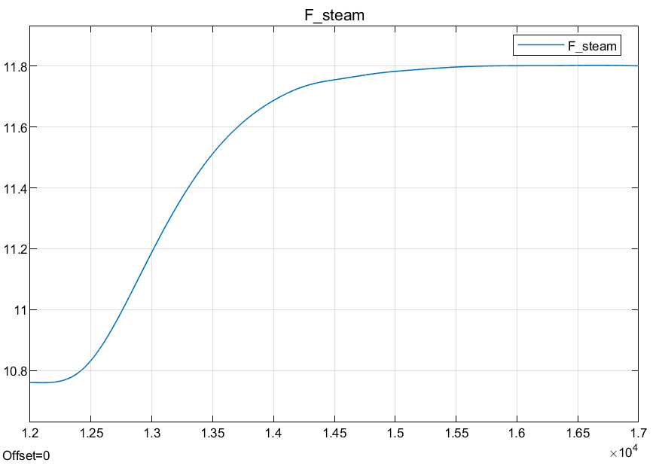

## Remarks

There takeaways from these plots are summarized in the table below. There are several points that could be commented upon, but for the purpose of this document, we only consider whether there is a response at all, and whether it is increasing or decreasing. Be aware that the primary air flow only increases the steam production until a certain point based on the stochiometric oxygen content of the waste, but that will not be considered in this document.

|  |  |  |  |
| --- | --- | --- | --- |
| **MV** | **CV** | **Transient response** | **Steady-state response** |
| Primary air flow | Flue gas oxygen | None | Increase |
|  | Turbine steam | Increase | Increase |
| Secondary air flow | Flue gas oxygen | None | Increase |
|  | Turbine steam | Increase | None |
| Grate speed | Flue gas oxygen | None | Decrease |
|  | Turbine steam | Increase | None |
| Waste feed | Flue gas oxygen | None | Decrease |
|  | Turbine steam | None | Increase |

# The strategy

By inspecting the step response table above, one notices that all MVs affect both CVs to some degree. This is what makes the control problem interesting. The Returkraft strategy is based on serial line of thought, beginning with the open-loop system as shown in figure 2a.

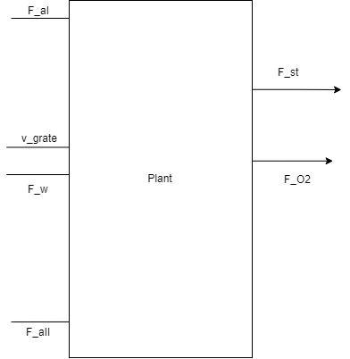

Figure 2a

## Oxygen control

First, we want to control only the O2 percentage, with as little effect on the steam as possible. The step response table above shows that the secondary air flow is a natural choice, since it only affects the steam production temporarily. We therefore create PID feedback from F_O2 to F_aII, as shown in figure 2b.

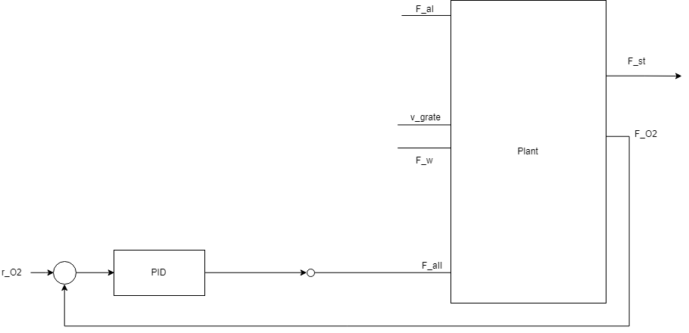

Figure 2b

## Steam control

Now we want to add control of the steam production. Returkraft chose to use the primary air flow for this, and we introduce PID feedback accordingly, as shown in figure 2c.

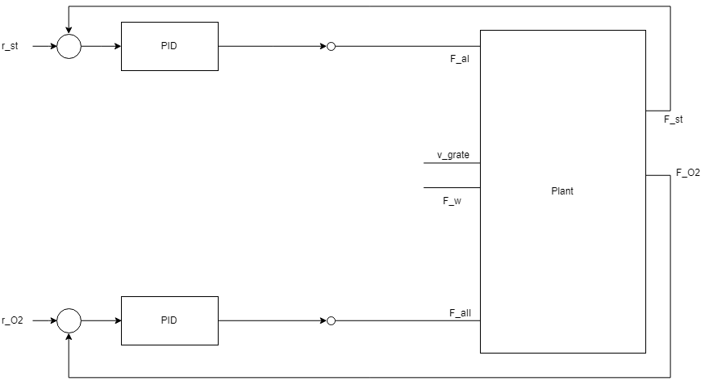

Figure 2c

## A/B control

Now we are in principle done, as we control both O2 and steam production. However, there is a problem – as shown in the step response table, the primary air flow affects the O2 percentage to a large degree. This means that if the steam production setpoint is increased and the primary air flow is increased accordingly, the O2 controller will reduce secondary air flow to maintain a constant O2 output. This can lead to low secondary air flows, which reduces the efficiency of the secondary combustion. Furthermore, at large steam setpoint changes, the O2 controller can decide to make the secondary air flow negative, which is not favourable.

To counteract this effect, another CV is introduced: the ratio of the primary to the secondary air flow. We name this A/B. Returkraft uses a setpoint of 1.6.

To control A/B, a novel strategy is used. First, we decide to use the waste feed as the manipulated variable. That is, we use a PID controller to translate the A/B deviation into a waste feed signal, as shown in figure 2d.

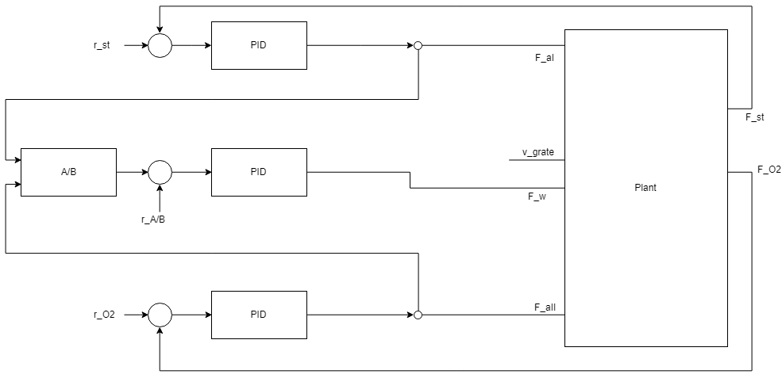

Figure 2d

To understand why this works, consider the case where the A/B process value is higher than the setpoint. This makes the waste feed increase, which in turn increases the steam production and reduces the O2 percentage. To compensate, the steam controller reduces the primary air flow (A) , while the O2 controller increases the secondary air flow (B). This reduces the fraction A/B, as required.

In this way, by using the grate speed and waste feed to control the A/B value, the O2 and steam production are effectively decoupled.

## Grate speed / waste flow distribution

Finally, to improve the response time of the A/B control, the grate speed and waste feed are controlled at a fixed ratio, as shown in figure 2e. The exact distribution is not of importance.

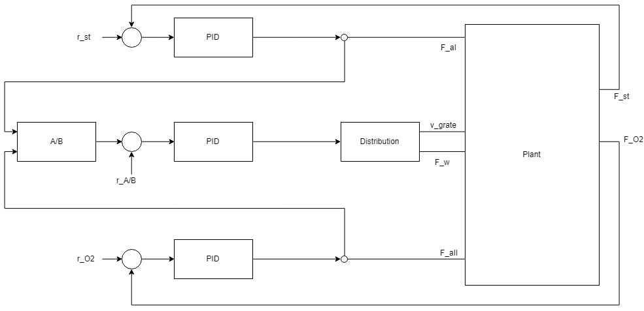

Figure 2e

## Remarks

The resulting controller in effect decouples the O2 and steam controllers. An example of a closed-loop response to a step in the waste production setpoint is shown in figure 4, with setpoints (in arbitrary units) given as F_O2 = 5, F_st = 13, A/B = 1.6.

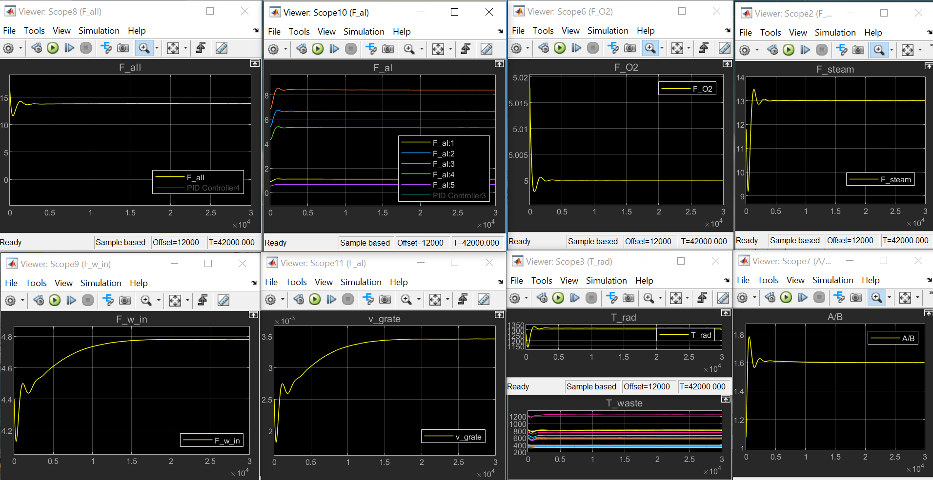

# Conclusion

Returkraft introduces a pseudovariable A/B controlled by ram speed and waste feed to almost independently control the O2 and steam controllers.